IR U 4
Text Classification is the process of automatically assigning predefined categories or labels to text documents. It is a major task in Natural Language Processing (NLP) and Information Retrieval systems. The goal is to analyze the content of a document and determine the class it belongs to based on patterns learned from training data.

Key Concepts
- Supervised learning: The model learns from a labeled dataset.
- Document representation: Text is converted into numerical vectors using bag-of-words, TF-IDF, or embeddings.
- Learning algorithms: Models such as Naive Bayes, KNN, SVM, and neural networks are used.

Process
- Preprocessing: Tokenization, stop-word removal, stemming, normalization.
- Feature Extraction: Converting text into vectors.
- Training: Model identifies patterns using labeled examples.
- Prediction: New documents are assigned the most likely class.

Applications
- Email spam detection
- Sentiment analysis
- News categorization
- Document indexing and filtering

Advantages
- Scales to large datasets
- Automates manual classification
- Provides quick, consistent decisions

Naive Bayes Model for Text Classification
The Naive Bayes model is a probabilistic text classification technique based on Bayes’ theorem. It classifies a document by calculating how likely it belongs to each class, given the words it contains. The model is called “naive” because it assumes that all words in a document occur independently of each other, which simplifies computation.

How Naive Bayes Works in Text Classification
- The system first learns from a labeled dataset where each document has a known category.
- It calculates how often each word occurs in documents of each class.
- For a new document, the model evaluates how strongly its words indicate each class.
- The class that gets the highest overall probability is selected as the predicted label.

Why Naive Bayes Works Well
- Text data is high-dimensional; Naive Bayes handles thousands of features easily.
- The independence assumption works surprisingly well in practice.
- It is very fast and efficient for both training and classification.

Applications of Naive Bayes Classifier
1. Text Classification
Used to categorize documents such as news articles or research papers based on word probabilities.
Performs well on high-dimensional text data.
2. Spam Email Filtering
Classifies emails as spam or non-spam using frequencies of suspicious words.
Fast and widely used in real-time email systems.
3. Sentiment Analysis
Determines whether text expresses positive, negative, or neutral sentiment.
Commonly applied to reviews, tweets, and feedback analysis.
4. Medical Diagnosis
Predicts the likelihood of diseases based on symptoms and patient data.
Helps in decision support systems for healthcare.
5. Recommendation Systems
Suggests products or content based on user preferences and past behavior.
Uses probability to predict user interest.
6. Fraud Detection
Identifies fraudulent transactions by classifying activities as normal or abnormal.
Useful due to its speed and ability to handle large datasets.

Advantages
- Extremely fast and scalable
- Requires small training data
- Performs well even when data is noisy
- Easy to implement

Limitations
- Fails to capture relationships between words (context)
- Independence assumption is unrealistic but practical

K-Nearest Neighbor (KNN) for Text Classification
K-Nearest Neighbor is a simple, instance-based learning method used for classifying text documents. Unlike other algorithms, KNN does not build an explicit training model. Instead, it classifies a new document based on how similar it is to previously labeled documents.

Working of KNN in Text Classification
- Convert documents into numerical vectors using representations like TF-IDF.
- When a new document arrives, compute its similarity to all existing documents using cosine similarity or distance measures.
- Select the k nearest documents (neighbors) that are most similar.
- Assign the new document to the class that occurs most frequently among these k neighbors.

Strengths
- Very simple and intuitive
- No training phase; the algorithm learns directly from stored data
- Works well for multi-class classification
- Effective for smaller datasets and non-linear decision boundaries

Weaknesses
- Slow classification process since it compares with every document
- Requires large memory to store all training documents
- Sensitive to noise and irrelevant features
- Performance depends heavily on the value of k and similarity metric

Applications
- Document recommendation
- Topic classification
- Basic categorization tasks in small systems
KNN is widely used as an easy-to-understand baseline model and performs well when data is clean and properly represented.

Spam Filtering
Spam filtering is a text classification task used to automatically detect and block unwanted email messages. It is one of the earliest successful applications of machine learning in text classification.

Purpose of Spam Filtering
Spam messages often contain phishing attempts, malware links, fake promotions, and advertising content. Filtering helps protect users and ensures inbox cleanliness.

How Spam Filtering Works
- Collect a dataset of spam and non-spam emails.
- Extract features such as word occurrences, sender address patterns, suspicious URLs, and email structure.
- Train a classification model such as Naive Bayes, Support Vector Machine, KNN, or neural networks.
- Apply the trained model to new emails to classify them as spam or legitimate.

Techniques Used
- Naive Bayes filters (most common due to speed and accuracy)
- Rule-based filtering using keywords and patterns
- Blacklists and whitelists
- Machine learning-based classifiers
- Heuristic patterns (e.g., excessive symbols, promotional language)

Common Indicators of Spam
- Words like “FREE”, “WIN”, “LIMITED OFFER”
- Suspicious sender domains
- Embedded tracking links or malware URLs
- Strange formatting or repeated characters

Advantages
- Protects users from phishing and fraud
- Reduces risk of malware infection
- Saves time by keeping inbox clean
- Highly accurate when trained with quality data

Limitations
- Spammers constantly change strategies
- False positives may block important emails
- Requires continuous updating and retraining
Spam filtering remains a crucial real-world application of text classification and forms a core part of email services today.

Support Vector Machine (SVM) Classifier
Support Vector Machine (SVM) is a powerful supervised learning algorithm widely used in text classification because it performs extremely well in high-dimensional spaces. Text data often contains thousands of features (words), and SVM is specifically designed to handle such situations.

Basic Principle
SVM aims to find the best separating boundary, known as a hyperplane, that divides documents of different classes.
The key idea is to choose the hyperplane that maximizes the margin, i.e., the distance between the hyperplane and the nearest data points from each class (called support vectors).
A larger margin generally leads to better generalization and classification accuracy.

Why SVM Works Well for Text
- Text features are high-dimensional and sparse—SVM handles this efficiently.
- It is robust to noise and irrelevant features.
- SVM can model both linear and non-linear patterns using kernel functions.
- It produces strong classification accuracy even with limited training data.

Key Characteristics
- Uses only the most informative points (support vectors) to define the decision boundary.
- Can handle multi-class classification with appropriate extensions.
- Avoids overfitting by maximizing the margin.

Advantages
- Very high accuracy for text classification tasks.
- Good performance for large feature spaces such as TF-IDF vectors.
- Works well when classes are well separated.
- Effective for spam filtering, sentiment analysis, and topic categorization.

Limitations
- Training can be slow on extremely large datasets.
- Requires careful tuning of parameters such as C and kernel type.
- Less interpretable compared to simpler models.

Vector Space Classification Using Hyperplanes
The Vector Space Model converts documents into numerical vectors where each dimension corresponds to a term (word) or feature. Classification in this space involves separating these vectors using hyperplanes.

Concept of Hyperplanes
A hyperplane is a linear decision boundary that divides the feature space into regions corresponding to different classes.
Text classification models like SVM, perceptron, and logistic regression rely on hyperplanes to determine class membership.

How It Works
- Convert documents into vectors using representations like Bag-of-Words or TF-IDF.
- Each document becomes a point in a high-dimensional space.
- The model identifies a hyperplane that best separates documents of different categories.
- Documents fall on one side or the other depending on their features.
- New documents are classified based on their position relative to the hyperplane.

Advantages
- Works very well for high-dimensional text data.
- Provides a clean geometric interpretation of classification.
- Can handle thousands of features without complexity issues.
- Forms the theoretical backbone of many modern classification algorithms.

Applications
- Spam vs non-spam classification
- Topic identification
- Sentiment classification
- Document clustering and categorization

3. Kernel Function
Kernel functions are mathematical tools used to extend linear classifiers like SVM to solve non-linear classification problems. They allow the classifier to operate in a higher-dimensional space without explicitly computing the coordinates in that space. This is known as the kernel trick.

Purpose of Kernel Functions
- Many classification problems cannot be separated by a straight hyperplane.
- Kernel functions transform data into a new space where the classes become linearly separable.
- This transformation is done implicitly, making the computation efficient.

1. Linear Kernel

K(x,y)=x⋅y

Key Points:
- Best suited for linearly separable data
- Widely used in text classification
- Works efficiently with high-dimensional sparse data
- Fast computation and low memory usage

2. Polynomial Kernel

K(x,y)=(x⋅y+c)d

Key Points:
- Captures feature interactions up to degree d
- Useful for non-linear but structured relationships
- Higher degree increases model complexity
- Risk of overfitting for large d

3. Radial Basis Function (RBF) Kernel

K(x,y)=exp⁡(−γ∥x−y∥^2)

Key Points:
- Handles complex non-linear decision boundaries
- Maps data into infinite-dimensional space
- Very powerful for complex datasets
- Sensitive to parameter γ

4. Sigmoid Kernel

K(x,y)=tanh⁡(α x⋅y+c)

Key Points:
- Inspired by neural network activation functions
- Suitable for specific applications
- Not always positive semi-definite
- Performance depends strongly on parameters

Advantages of Kernel Functions
- Allow flexible and powerful classifiers.
- Enable SVM to handle complex, non-linear patterns.
- Avoid explicit mapping to huge feature spaces, reducing computation cost.
- Work extremely well for tasks where a linear classifier is insufficient.

Limitations
- Some kernels require parameter tuning.
- Incorrect kernel choice can reduce accuracy.
- Computational cost increases for large datasets.

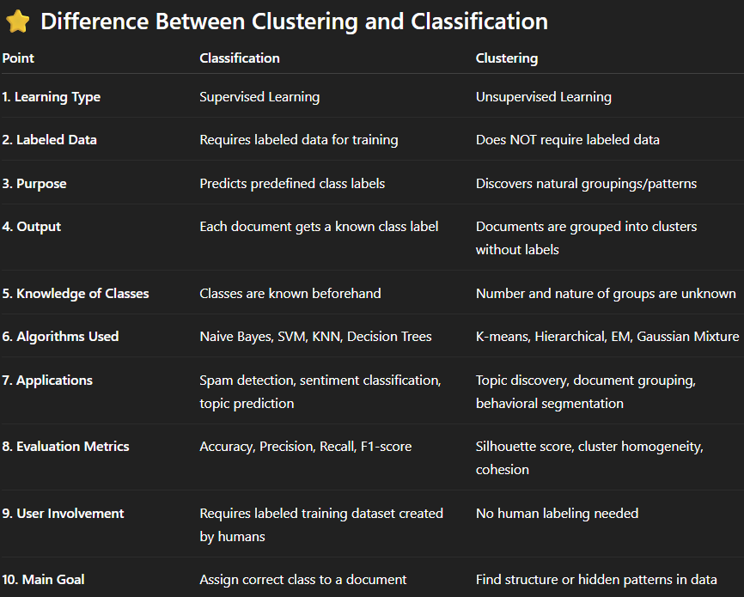

Can clustering be used for classification purposes?
Yes, clustering can be used for classification, but indirectly.
- Clustering is an unsupervised learning technique that groups data based on similarity without class labels.
- Classification is a supervised learning technique that assigns predefined labels to data.

How clustering helps in classification
- Labeling clusters
After clustering, each cluster can be assigned a class label based on the majority class of labeled samples in that cluster.
- New data classification
A new data point is assigned to the nearest cluster, and the cluster’s label is used as the predicted class.
- Feature generation
Cluster IDs or distances to clusters can be used as features in a classifier.

Example
- Customer data is clustered into 3 groups based on behavior.
- Later, clusters are labeled as Low-Value, Medium-Value, High-Value customers.
- New customers are classified by finding the closest cluster.

Partitioning Methods
Partitioning methods are a family of clustering techniques that divide a dataset into a fixed number of clusters. Each document is assigned to exactly one cluster based on similarity to a central representative.

1. Basic Idea
Partitioning methods treat clustering as an optimization problem. The dataset is partitioned into k clusters, and the algorithm tries to:
- Minimize within-cluster distance (documents in the same cluster are similar)
- Maximize between-cluster distance (different clusters are well separated)
The number of clusters k is usually user-defined.

2. Steps in Partitioning Methods
- Choose k, the number of clusters.
- Initialize cluster centers (randomly or using heuristics).
- Assign documents to the nearest cluster based on a similarity/distance measure.
- Update centroids based on newly assigned points.
- Repeat until the cluster assignments stabilize.
Distance is often computed using cosine similarity for text data.

3. Common Partitioning Algorithms

(a) K-Means Clustering
- Most widely used partitioning algorithm.
- Uses mean value of documents as the cluster center.
- Repeats assignment and update steps until convergence.

(b) K-Medoids / PAM
- Uses actual data points (medoids) instead of means as cluster centers.
- More robust to outliers than k-means.

(c) CLARANS (Clustering Large Applications)
- Designed for large datasets.
- Combines sampling with k-medoids for scalability.

4. Strengths of Partitioning Methods
- Simple and easy to implement
- Efficient for large datasets
- Produces compact and meaningful clusters
- Works well when clusters are spherical and of similar size

5. Limitations
- Requires the user to specify the number of clusters (k).
- Sensitive to initial cluster centers.
- Not suitable for clusters with irregular shapes.
- Can get stuck in local optima.

6. Applications
- Text document grouping
- Customer segmentation
- Image clustering
- Topic discovery
- Web page grouping

K-Means Clustering for Text Clustering
K-means is one of the most popular algorithms used for text clustering, where the goal is to group similar documents together. It is a partitioning-based method that divides documents into k clusters, each represented by a centroid, which is the average vector of documents in that cluster.

How K-Means Works in Text Mining
- Choose k, the number of clusters (topics).
- Initialize centroids randomly from the document vectors.
- Assignment Step:
Assign each document to the nearest centroid using cosine similarity, which works well for text.
- Update Step:
Recompute each centroid as the mean TF-IDF vector of documents in that cluster.
- Repeat the two steps until assignments stabilize.

Key Features for Text
- Represents documents as high-dimensional vectors (TF-IDF).
- Minimizes distance between documents and cluster centroid.
- Efficient for large collections like news articles, webpages, tweets.

Advantages
- Simple and fast even for millions of documents.
- Easy to implement and understand.
- Suitable for text datasets with well-defined topical clusters.

Limitations
- Requires pre-setting k, the number of topics.
- Sensitive to noisy or outlier documents.
- Clusters may not be meaningful if documents overlap in topics.
- Initialization affects final clusters.

Text Applications
- Topic grouping of news articles
- Clustering search engine results
- Document organization in digital libraries

Agglomerative Hierarchical Clustering for Text
Agglomerative hierarchical clustering is a bottom-up text clustering method that builds a hierarchical structure called a dendrogram. It is highly useful for exploring document similarity relationships.

How It Works
- Begin with each document as a separate cluster.
- Compute similarity between all pairs using cosine similarity (best for text).
- Merge the two most similar clusters.
- Update similarity matrix.
- Repeat merging until all documents form a single tree-like structure.

Linkage Methods
- Single linkage: merges closest pair of documents.
- Complete linkage: merges clusters based on their farthest documents.
- Average linkage: averages distances.

Advantages
- No need to specify number of clusters; choose by cutting the dendrogram.
- Reveals hierarchical and nested document groups.
- Useful when studying how documents relate at multiple levels.

Limitations
- Computationally expensive for large text datasets.
- Once two clusters merge, it cannot be undone.
- Sensitive to noisy text or very short documents.

Text Applications
- Organizing research papers
- Building topic hierarchies
- Visualizing similarity between text documents

Expectation-Maximization (EM) Algorithm for Text Clustering
EM is a probabilistic clustering method which performs soft clustering, meaning each document belongs to clusters with certain probabilities. This captures the fact that documents may relate to multiple topics.

Two-Step Process

1. E-Step (Expectation Step)
- Compute the probability that each document belongs to each cluster.
- This uses current cluster parameters (means, variances).

2. M-Step (Maximization Step)
- Update cluster parameters using the probabilities calculated in E-step.
- Refines cluster centroids and spreads.
These steps repeat until there is no significant improvement.

Why EM is Good for Text
- Handles overlapping topics (e.g., a sports-business article).
- Assigns partial membership, which reflects real document behavior.
- More flexible than k-means because clusters can take different shapes.

Advantages
- Produces soft, probabilistic clusters.
- Useful for complex and ambiguous document sets.
- Works well when documents may belong to multiple topics.

Limitations
- Slower and more computationally expensive than k-means.
- Sensitive to initialization; may converge to local optima.
- Often uses k-means to get initial cluster positions.

Text Applications
- Clustering mixed-topic articles
- Soft topic assignment in news or blogs
- Document classification with overlapping themes

Mixture of Gaussians Model (GMM) for Text Clustering
A Gaussian Mixture Model assumes that text documents are generated from multiple Gaussian distributions, each representing a different cluster or topic. It is one of the most powerful probabilistic clustering methods.

Key Concepts for Text
- Each cluster corresponds to a Gaussian distribution in vector space.
- Documents have probable membership, not fixed membership.
- The EM algorithm estimates parameters for each Gaussian.

How GMM Works
- Initialize Gaussian parameters (mean, covariance, weight).
- E-Step: Compute probability of each document belonging to each Gaussian cluster.
- M-Step: Update the Gaussian parameters using these probabilities.
- Repeat until convergence.

Advantages
- Can model elliptical or unevenly shaped clusters, unlike k-means.
- Handles overlapping document groups naturally.
- Provides a full probabilistic interpretation of text clusters.
- More flexible than k-means because each Gaussian can have its own shape.

Limitations
- Computationally expensive for large text datasets.
- Requires assuming text data fits a Gaussian distribution.
- Sensitive to initialization.

Text Applications
- Topic modelling
- Grouping articles by complex themes
- Anomaly detection in textual logs or emails
- Speaker/document identification

